**AWS S3 : Simple Storage Service**

**1.What is AWS S3 Bucket?**

**An Amazon S3 bucket is a public cloud storage resource available in Amazon Web Services’ (AWS) Simple Storage Service (S3), an object storage offering. Amazon S3 bucket, which are similar to file folders, store objects, which consists of data.**

**2.Why do we need S3 Bucket?**

**If your business need lot of object storage requirements, i.e job portal – resume, banking – documents, vehicle sales – multiple car pictures & documents, etc.**

**Points to remember:**

1. **S3 – Object based storage / flat files.**
2. **S3-Buckets similar to folders.**
3. **S3-It is region based and highly available.**
4. **S3-Maximum 100 buckets per region.**
5. **S3-Supporta data redundancy.**
6. **S3-Allowed file sizes – 0 bytes to 5 TB.**
7. **S3-Unlimited Storage Supported.**
8. **S3-Bucket Name should be Unique.**
9. **S3- How the payment is calculated? Based on how much data has been stored.**
10. **S3- You can host a static website on Amazon S3.**

**Dynamic website relies on server-side processing, including server-side scripts such as PHP, JSP, or ASP.NET.**

**Amazon S3 does not support server-side scripting.**

**Demo:**

**Enter in to AWS S3 service**

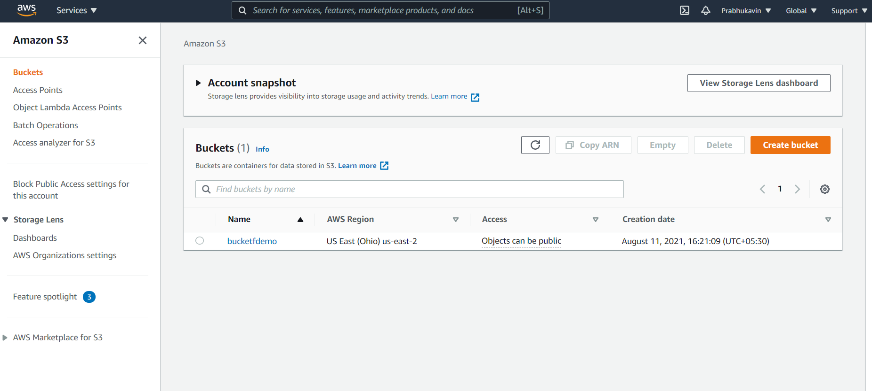

**Create a bucket by giving a UNIQUE name.**

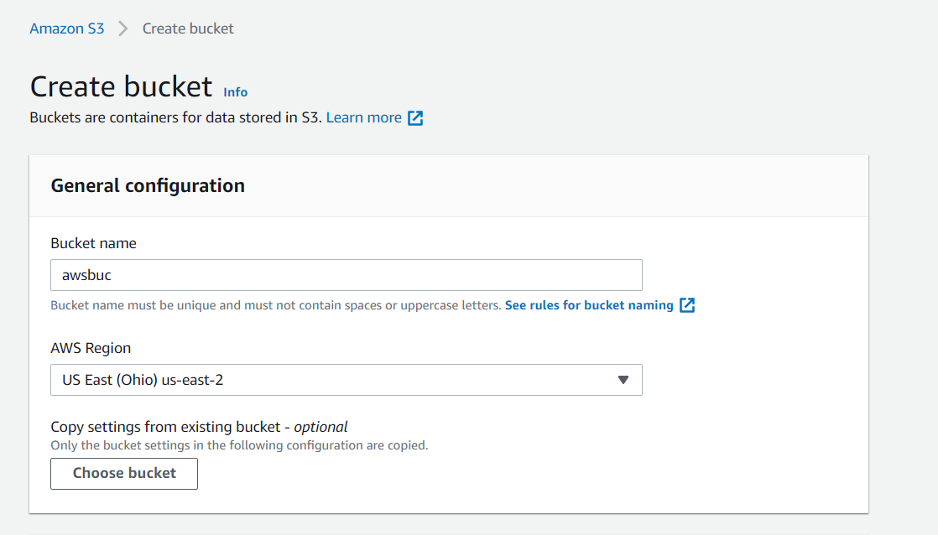

**Check out the “Block all public access”**

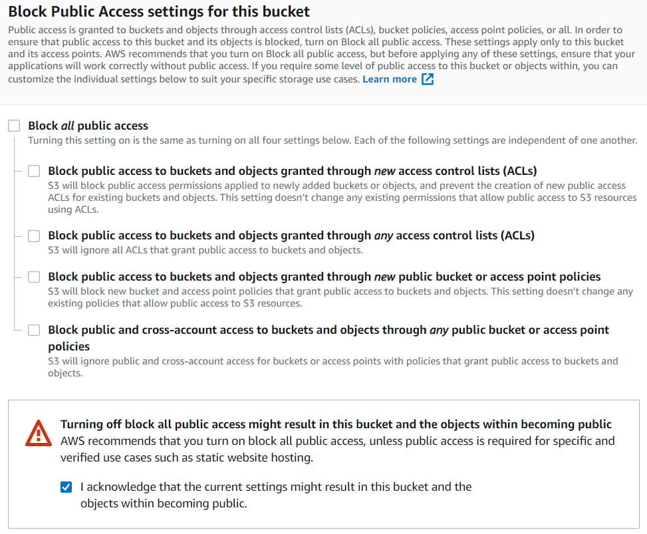

**Enable the Bucket Version:**

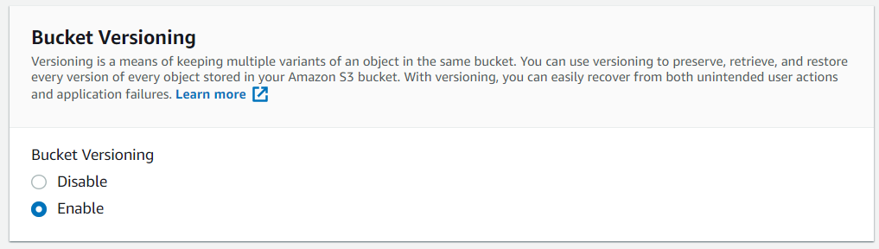

**Then click “Create bucket”**

**Now the bucket has been created successfully.**

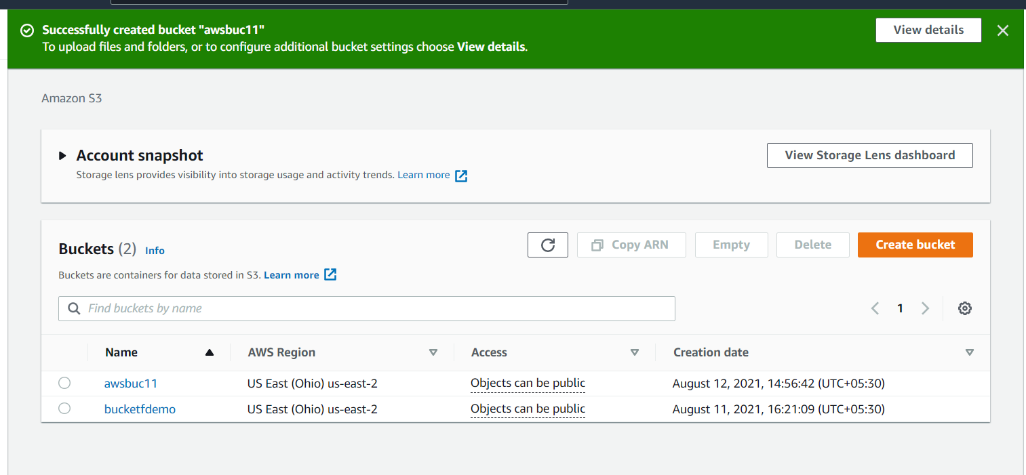

**To Give access to the public user go into the permissions tab and grant the permission to access by public user.**

**Upload some file in the S3 bucket.**